Stage 7 – Port of Entry
COURSE DESIGNER: Ike Starnes
SCORING: Comstock 22 rounds.
TARGETS: 10 cardboard targets, 2 steel targets
SCORED HITS: 2 Best hits per carboard will be scored.

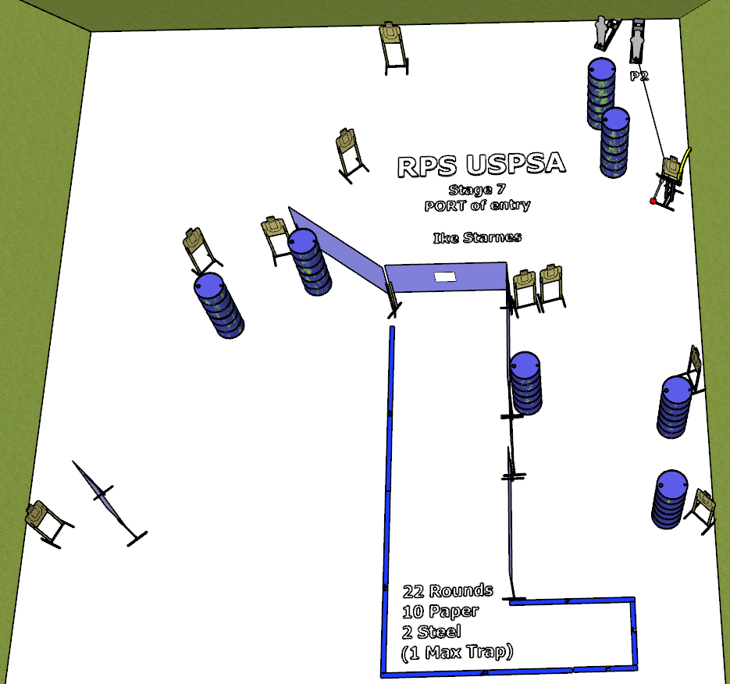

Written Stage Briefing:

Stage 7 – Port of Entry - is a 22 round, 110 point, Comstock Course. There are 10 cardboard targets and 2 steel targets.
Start position Anywhere inside the shooting area.
Handgun: Loaded and holstered, wrists below belt.
PCC: Loaded, stock touching belt.

On the audible start signal, engage targets from within the shooting area.

Popper 2 activates the Max Trap which remains visible at rest.

USPSA / NROI Range Commands:
- Make Ready
- Are you ready?
- Standby
- If finished, unload and show clear
- If clear, hammer down and holster (Handgun)
If clear, hammer down and flag (PCC)
If clear, cylinder closed and holster (Revolver)
- Range is clear

Setup Notes:
2 Single Wall Stands
4 Double Wall Stands
3 Full Walls
1 Port Wall
1 Half Port Wall
9 Target stands / 18 target sticks
1 Max Trap + cables
1 Activator Popper
1 Popper
14+ barrels


